XML Lab1
- Write Xml file named family with the following structure
Don’t Use Mixed Content Element.
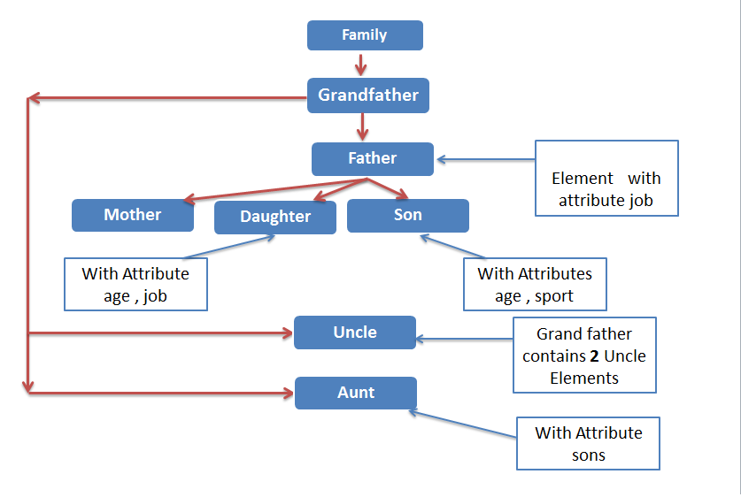
For the previous Xml file write the DTD file with the following rules
- Job attribute with father and daughter Elements has a value from (Engineer, Accountant, Doctor) and set the default value for it with Engineer
- Age attribute with Daughter and son Elements is Required and has NMTOKEN value
- Sport attribute with son Element has a value from( tennis , football )
Default value football.
- Sons attribute with Aunt Element is Optional
-------------------------------------------------------------------------------------
- Write DTD file for POrder.xml file.
-------------------------------------------------------------------------------------

